**Face Detection for project**

 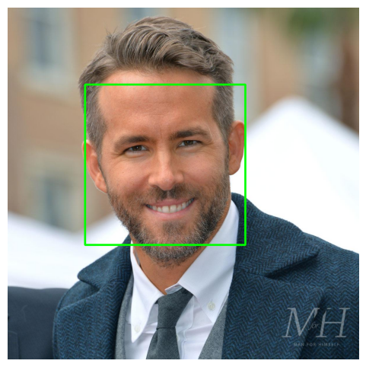

Here we are work with face detection, Initially, the algorithm needs a lot of positive images and negative images of faces to train the classifier. Then we need to extract features from it. The algorithm works by breaking down an image into small rectangular regions and then applying a series of classifiers to each regions to determine whether it contains the object of interest or not. Once the Haar-like features have been computes for each region of the image, the Ada-boost algorithm is used to train a series of classifiers that can be used to distinguish between positive and negative examples of the object of interest.

In this project, we Implemented a system for locating face in digital images.Face detection uses classifiers, which are algorithms that detects what is either a face(1) or not a face(0) in image.

The Haar cascade algorithm uses a set of haar-like features to identify regions in an image that are likely to contain an object. These features are simple rectangular patterns that can be used to distinguish between the object and its background. On observation, the eye area appears darker than the check area while the nose area looks brighter than the eye area. You can visualize these feature in the below figure 3.



Fig 3 Face Model for Haar cascade

Using these features and the computations of pixels, the algorithm identifies more than 100000 data points.we can see in the Fig 3 that Haar Feature like Line feature, edge feature, etc are used to detect face region. Eyes, nose and Mouth are present in the same square than that square will be our face location.The training data used in this project is an XML File called: haarcascade_frontalface_default.xml.

Overall, the Haar cascade algorithm is a powerful and efficient technique for object detection that has been widely used in computer vision applications.

We are going to use the detectMultiscale module from OpenCV.what this does is create a rectangle with coordinates(x,y,w,h) around the face detected in image. This contains code parameters that are the most important to consider.

Workflow of face detection:-

1. Load the Haar Cascade Frontal Face Algorithm.
2. Initialize the camera
3. Read frames from the camera.
4. Convert color images into grayscale.
5. Get the face coordinates.
6. Draw a rectangle and put the appropriate message.
7. Display the output.